Convolutional Neural Network(CNN)
The term convolution comes from mathematics and is the act of combining two functions (f and g) and getting a third function (f*g). here is a good video on convolution: https://www.youtube.com/watch?v=KuXjwB4LzSA
the first formula we have is our image, and the second is our filter/kernel. The way we combine these two functions is as explained in the video that is linked above, but in case you don’t have time to watch it this is my best explanation of said video. To combine two functions we take the point those two functions describe, in the case of images we don’t need to bother with functions and can just jump straight to the numbers, when combining the numbers we first combine the “edge” of the two groups of numbers by multiplying and then adding every product, this is known as finding the dot product of the two sets of numbers, in the example of figure1 we would take -1*10, then -1*10 + 0*10, then -1*10+0*10+1*10, then -1*0+0*10+1*10 when you reach the edge you go to your original point and then down one, so -1*10+-1*10 and so on, but this is what would be normal in mathematics, in CNN we do not start where the edges touch we start where the two functions fully overlap, if you want the output to be the same size as the input you can add “padding” typically by adding 0 to the edges so that the input layer is two pixels taller and wider, the output in the image comes from “convolving” over the input with no padding, so (1*10+0*10+ -1*10)³ = 0 it is important to note that the values of the second function have to add up to 0, or else the values of our output will grow for each time we apply our filter
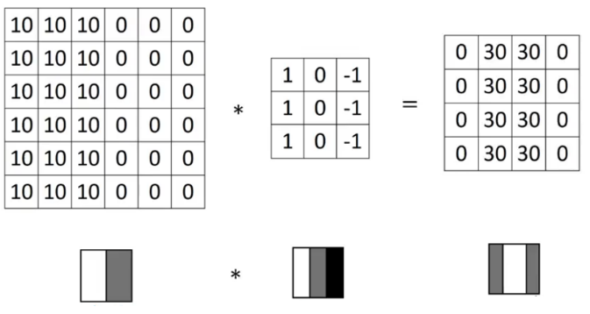Figure 1: example of adding a filter to image values

the output of adding a filter to a image is called the activation map (or feature map)
sometimes we don’t want to apply our filter to every part of the image, for example if we find that the resulting feature map is over-fitted, and the way we do this is by using an other stride valuation, strides is the number of pixels the filter “strides” before computing the next dot product, so if we have a stride value of 2 then the filter only finds the dot product of every other pixel on every row. Strides are typically never larger than 3.
If we want to compute some features of a colored image, a typical way to do this is to split the image into color channels, eg. RGB, and then convolve over each channel, making our Convolution layer more complex
the common variables used for convolution algorithms are
p = padding
f*f = size of filter
c = number of channels
s = strides
n*n*c = total size of input
f*f*c = total size of activation map
we do this with a seperate filter for each feature we want to find so that we have many feature maps, combining all this we can say that we have “neurons” that apply a filter to each part of a image using their “perceptive field”, and the collection of these neurons is the convolutional-layer
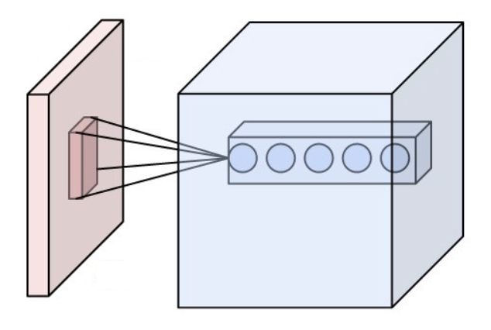Figure 2: image in red being red by a neuron in the convolutional-layer using it's perceptive field

As we apply a new convolutional-layer we detect increasingly abstract features by applying new sets of filters to the feature maps of ore previous convolution layer, when we have found all the features we want to detect we connect every neuron of each layer to every neuron of the next to create a fully connected layer, a fully connected layer is the same thing as a multilayer perceptron https://en.wikipedia.org/wiki/Multilayer_perceptron

pooling layers are used to reduce the size of an input, they compress the input using differing methods, som of the most common pooling layers are, L2-, Max- or Average-pooling. Pooling layers are typically added after convolution layers or as a last step of a convolution layer.

The activation function usally used for the fully connected layer is “RELU”

https://en.wikipedia.org/wiki/Convolution.

